Project Design Phase-II
Data Flow Diagram & User Stories

Date | 29-11-2025
Team ID
Project Name | DocSpot- Doctor Appointing Booking System
Maximum Marks | 4 Marks

Data Flow Diagrams:
A Data Flow Diagram (DFD) illustrates how data moves within the Doctor Appointment Booking System.
It explains how Patients, Doctors, and Admins interact with the platform, how medical and appointment information flows between components, and how records are stored.

DFD Level 0 – Doctor Appointment Booking System
The DFD Level 0 (Diagram) of the Doctor Appointment Booking System provides a high-level overview of how data flows between the system and its external entities.
It represents the entire system as a single unified process and shows how patients, doctors, and admins exchange information with it.
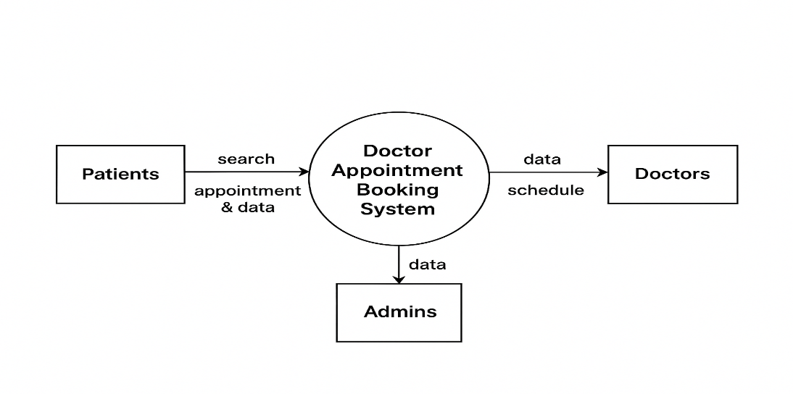
User Stories– Doctor Appointment Booking System
User Type | Functional Requirement | User Story / Task | Acceptance Criteria | Priority | Release
Patient | Doctor Search | As a patient, I want to search for doctors by specialization so I can find the right doctor easily. | Search results show correct doctors based on filters. | High | Sprint 1
Patient | Appointment Booking | As a patient, I want to book appointments based on available time slots. | Appointment is created and visible in both dashboards. | High | Sprint 1
Patient | Appointment Management | As a patient, I want to cancel or reschedule my bookings. | Updated appointments are reflected in the doctor and patient system. | Medium | Sprint 2
Patient | Medical Records | As a patient, I want to view my medical history and prescriptions. | Records display accurately for logged-in patients. | Medium | Sprint 2
Patient | Payments | As a patient, I want to make payments for online consultation. | Payment succeeds and generates a receipt. | High | Sprint 2
Patient | Notifications | As a patient, I want reminders for upcoming appointments. | Alert is sent before appointment time. | Low | Sprint 3
Doctor | Availability Setup | As a doctor, I want to set my available timings. | Patients can see only available time slots. | High | Sprint 1
Doctor | Appointment Dashboard | As a doctor, I want to view all upcoming appointments. | Upcoming bookings load with patient details. | Medium | Sprint 2
Doctor | Prescription Upload | As a doctor, I want to upload digital prescriptions. | Prescription appears in patient records. | Medium | Sprint 3
Admin | Doctor Verification | As an admin, I want to verify doctor profiles. | Only verified doctors can log in and set schedules. | High | Sprint 1
Admin | User Management | As an admin, I want to manage patient and doctor accounts. | Accounts can be activated, blocked, edited. | Medium | Sprint 2
Admin | System Monitoring | As an admin, I want to monitor system appointment logs. | Logs show accurate appointments and user activity. | Medium | Sprint 3

